Level Design Document - Template

# Level 1 – Tutorial Tundra

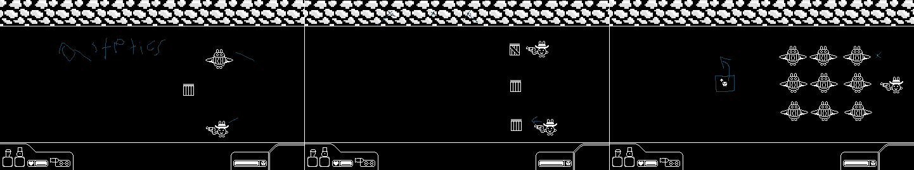

Rough Draft

This is the first stage of the game and as such it meant to introduce various mechanics, the first and foremost of these are the various types of enemy’s and objects, as such the first screen has all the main objects placed on them, or that was the goal, as I forgot to make some background objects that are interactable within it, as such I added cactuses to this part. I also added in some decorations to the stage as it was mostly barren, which was applied to all the screens in this part.

The second and third screen is meant to show off a variety of power ups that you can encounter across the crates in the game. The third one in particular is meant to use the Item obtained then in order to severely weaken the enemy group, where it will put the basic enemy into one shot range to be cleared out easy. Meanwhile the 2nd and third stage also introduce enemies using objects for cover from the ball.

As for the main changes here most of these were simply adjusting the positions of enemy to be uniform, as well as some basic aesthetics and the changes to level 1 and two via the cacti. I also used this to check my player’s size for future levels, which is indeed 48 pixels, and all other levels mae sure to give appropriate space for them.

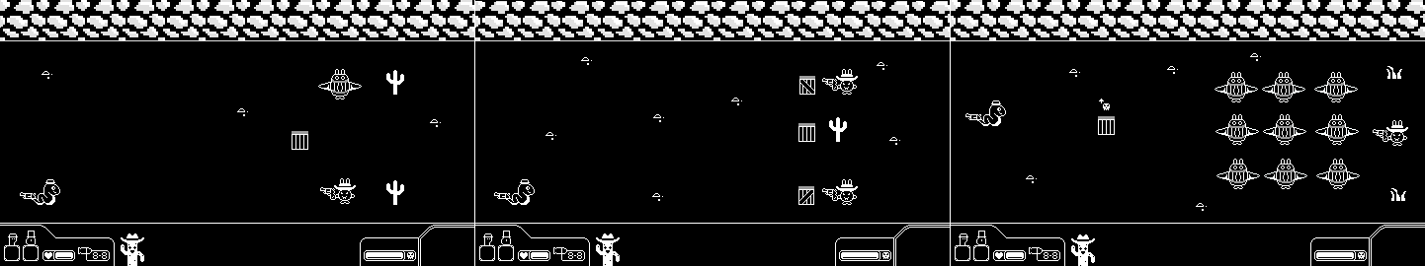

Final Draft

# Level 2 - Bad Bunny Bulavard

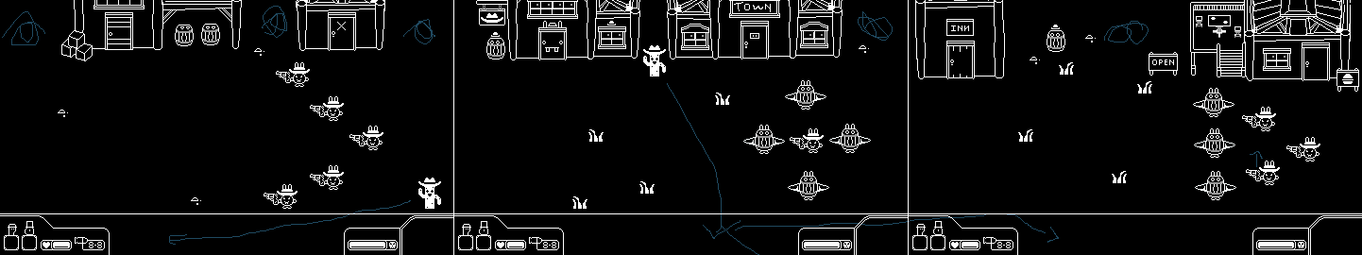

Rough Draft

This was the rough draft for the main gameplay level that will occur. The most noteworthy thing that was changed in this rough draft was making sure the ball wouldn’t get stuck in a top corner place by adding in details to it.

The main initial design of this level is to show you that there are some situations where bullets are better then ball and vice versa. The first stage features mainly the gun enemies which are weak to the ball, the second stage is an enemy stuck in the barrel foes, which makes it better to use bullets on them. And the third stage is the combination of the ideas starting with gun use to get behind the enemies to dispatch the horde.

Overall the final draft features a bit more decorations and such to keep the player in the stage and enhance game feel, as well as adjustment to make the initial positioning more uniform.

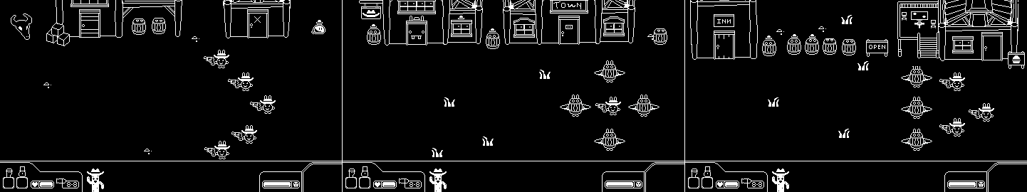

Final Draft

# Level 3– Barron Bunny Burgers and Blasters

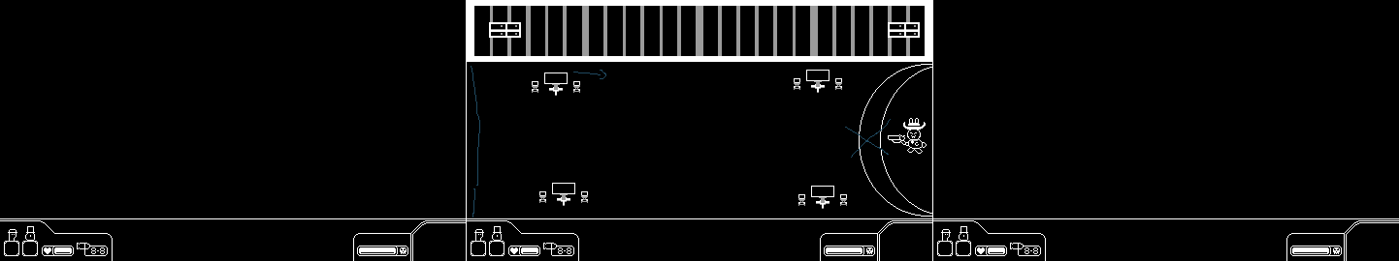

Rough Draft -

This is the final level of the game, and is the first ever boss fight. The initial level design was one screen and for the most part I liked the layout – But needed to do some certain adjustments, In particular the tables needed moving around to be more organized, and I wanted more room for where the ball could stay around that area, perhaps allowing you to deal a lot of dmg depending on how collisions work or otherwise. Also, the tables in front were moved to make it fit the plan

Another thing that was wanted was on the side I wanted spikes to make the area more dangerous if you don’t hit the ball back to the boss however the tables should also help keep this from happening most of the time as well, it is the first boss after all.

Other then that more aesthetical clean up was done to make the level look better and with that I say that the level is now an appropriate arena for the barren

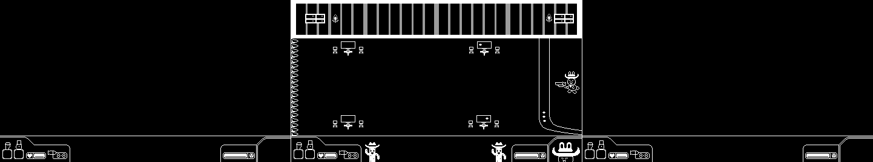

Final Draft –